OUTPUT: P1
Create Table
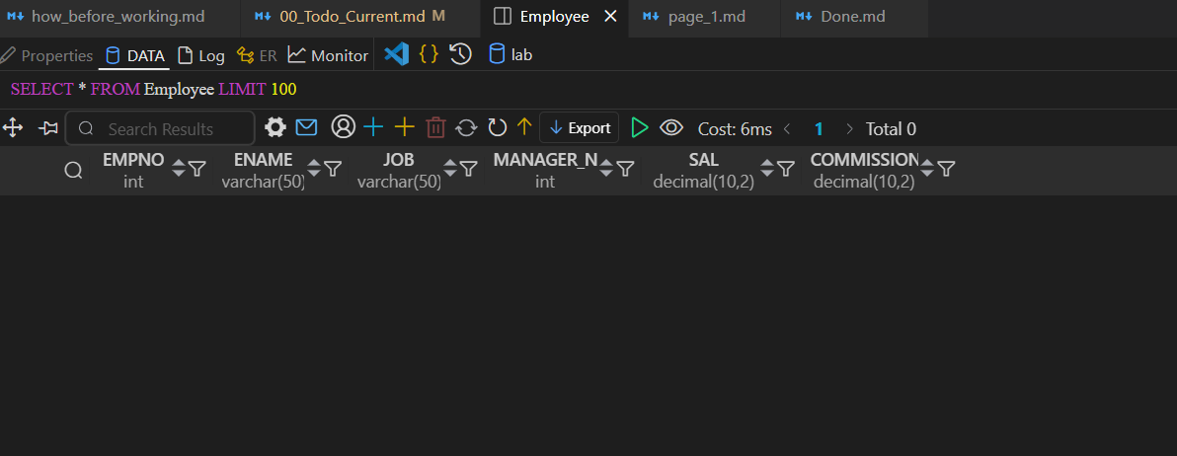

Create User & Grant Permissions
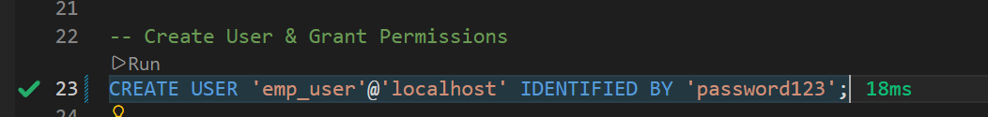
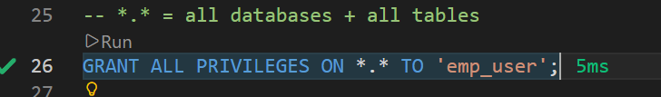

Insert Records + Roll Back
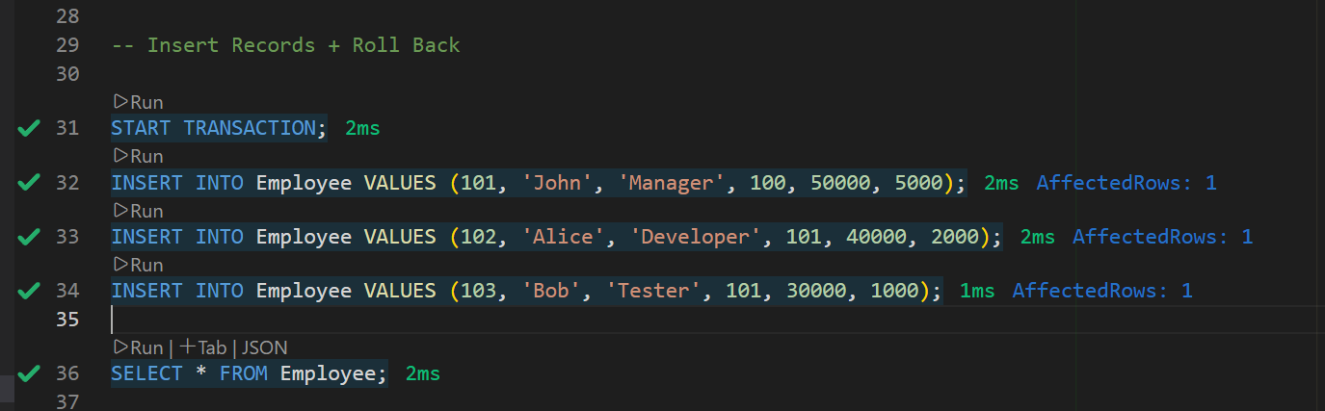

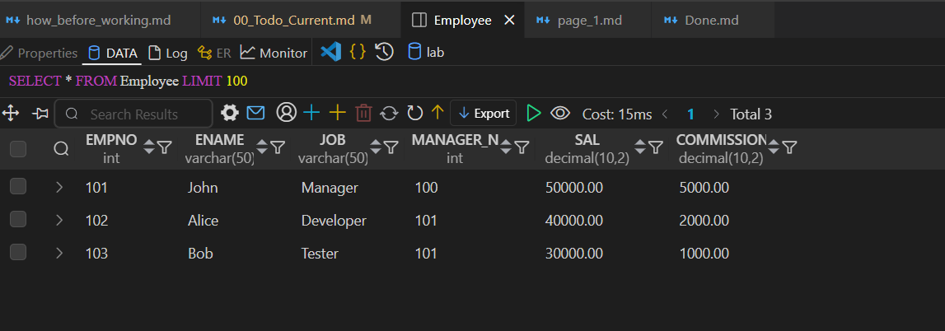

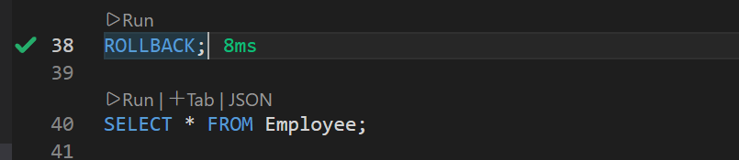


ADD CONSTRAINTS
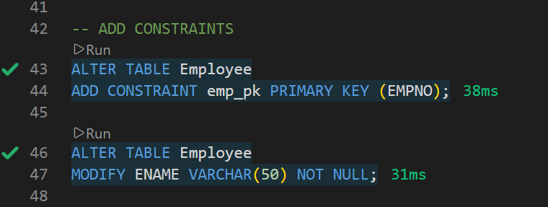

Insert NULL Values (Test Constraints)

OUTPUT: P2
Add a column commission with domain to the Employeetable.
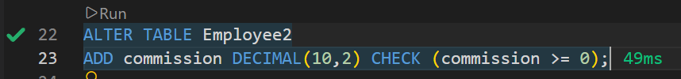
Cheking Constraint
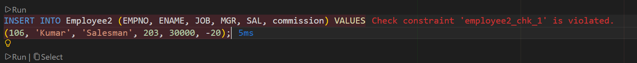
3. Update the column details of job
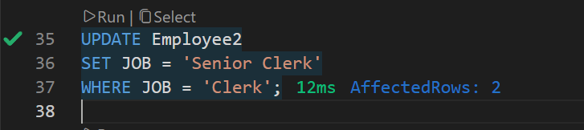
4. Rename the column of Employ table using alter command.
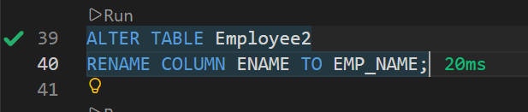

5. Delete the employee whose Empno is 105.
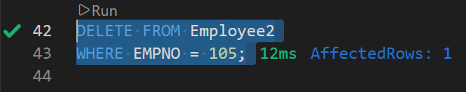
6. Final Table
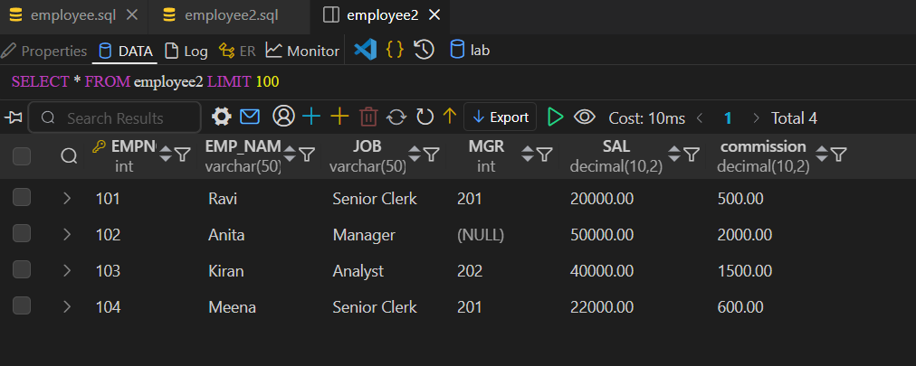
OUTPUT: P3
- Create Employeea table and inserting data
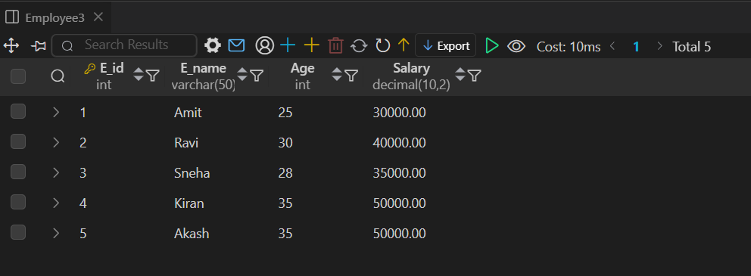
2. Count number of employee names from employeetable
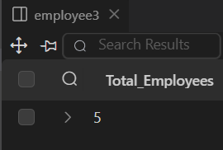
- Max age
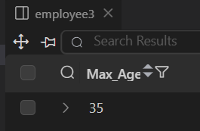
- Min Age
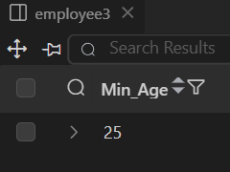
- Salary In Ascending Order
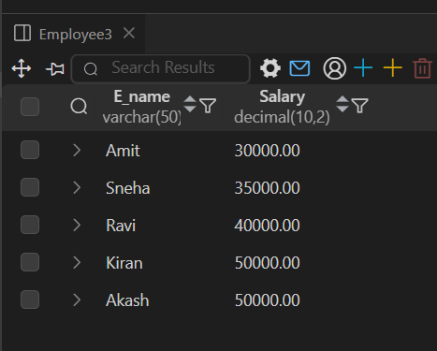
- Grouped Salaries of Employees
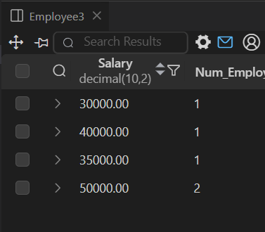
OUTPUT: P4
Customer Table Sample Data
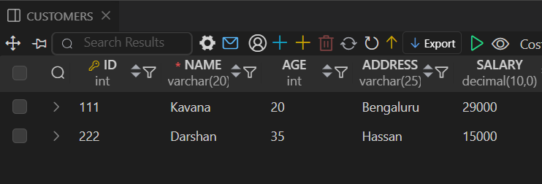
Trigger
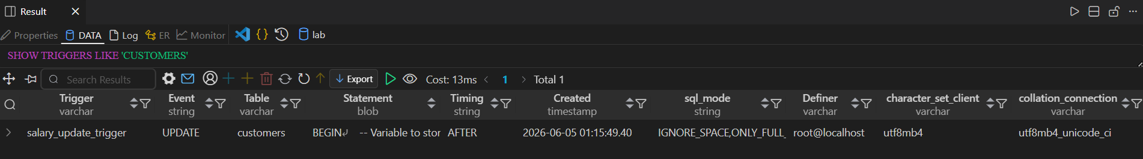
Testing Update Trigger
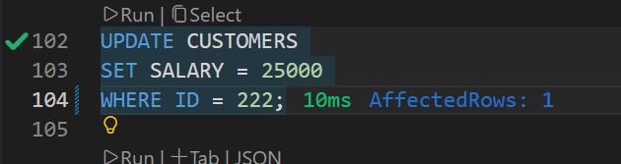
Trigger
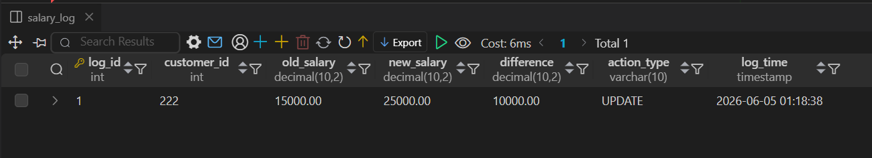

OUTPUT: P5

Table created and populated
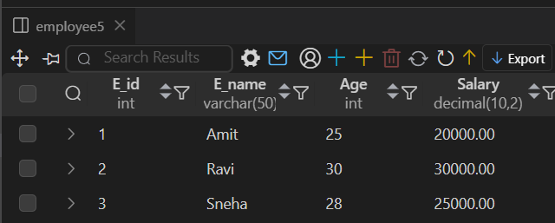
Proedure Called
Result 1
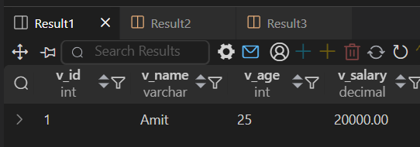
Result 2
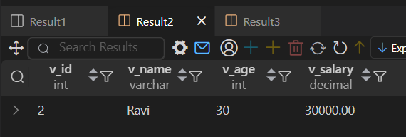
Result 3
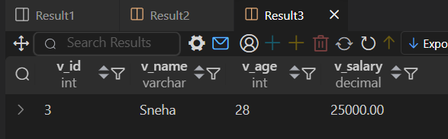
OUTPUT: P6
O_RollCall Table with populated Data
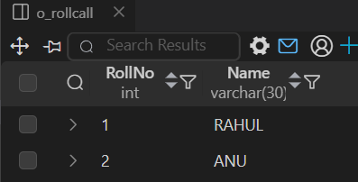
N_RollCall with Populated Data
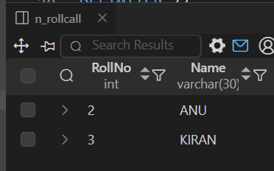
Merge_RollCAll Call Called
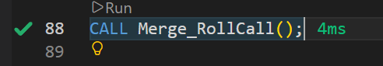
Final Merged Table
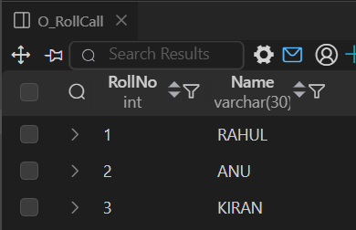

OUTPUT: P7
Insert Operation
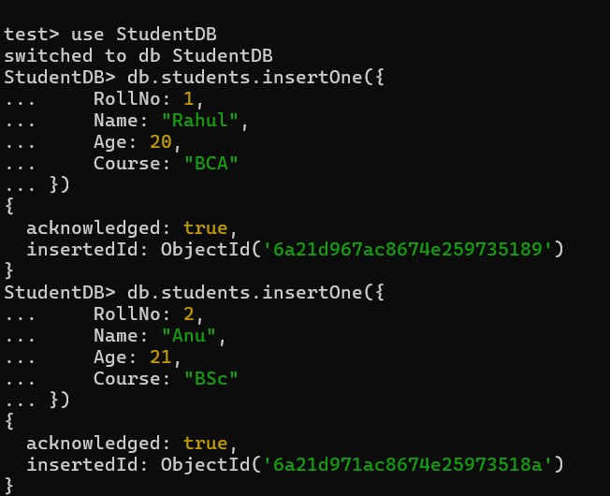
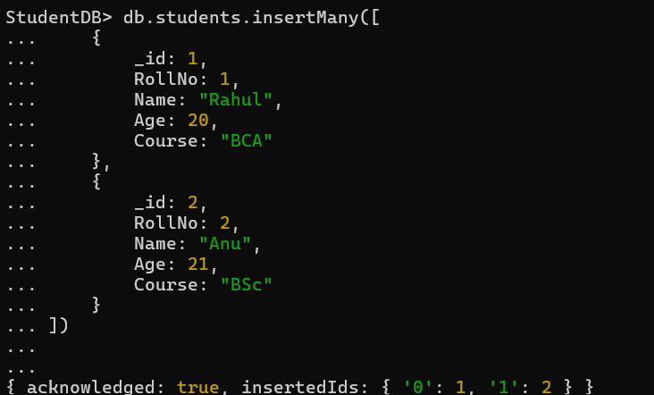
Read Operation
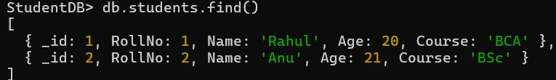
Update Operation
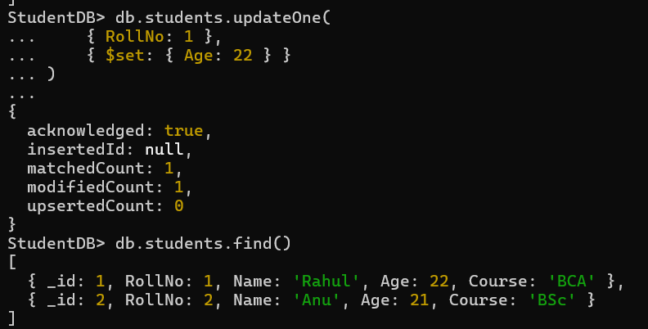

Delete Operation
